Phan Dinh Linh
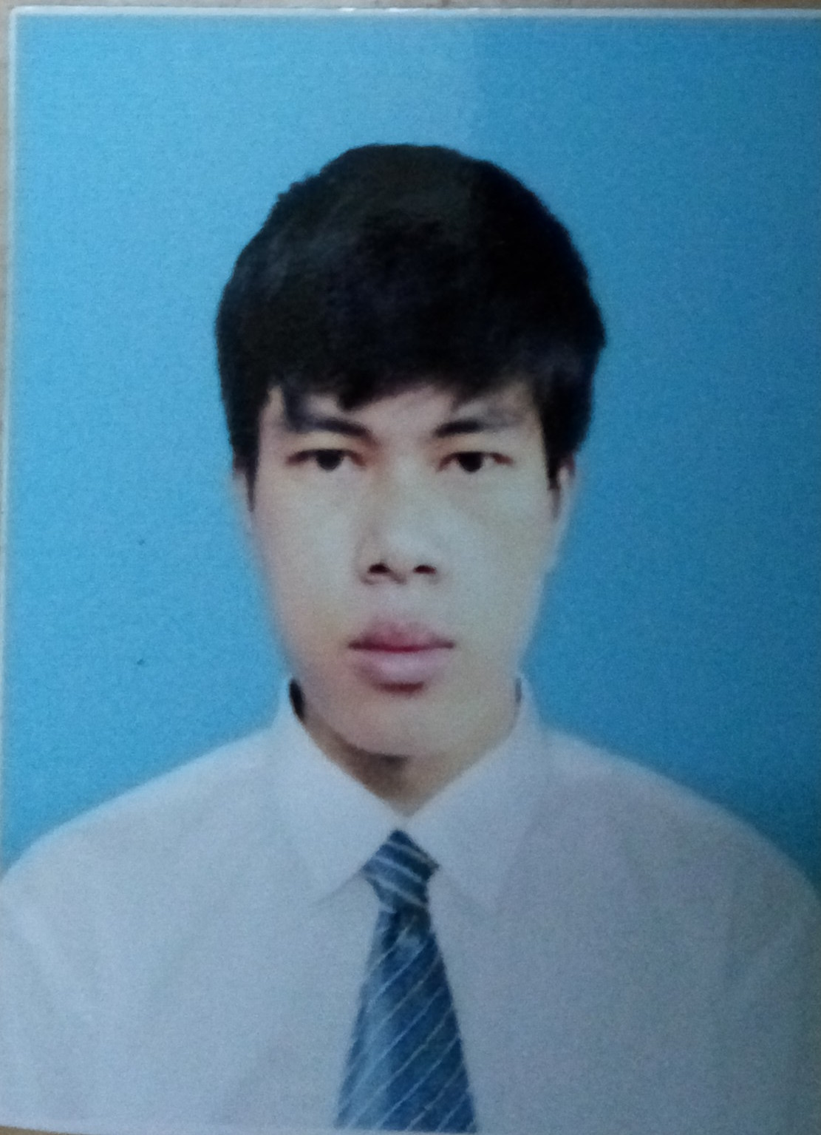
Date of Birth: 1st Aug 1989
Address: 441/67c – Dien Bien Phu Street– Binh Thanh District – Ho Chi Minh City.
Mobile: 0168-5918-345
E-mail: linhphan0108@gmail.com
Linkedin: https://vn.linkedin.com/in/linhphan534
Blog: https://linhphanit.wordpress.com/
SUMMARY:
The software engineer with nearly 2-year experience in Android development using Android SDK, object-oriented programming, Android Studio.
Good at Java, OOP, code conventions, version control systems (Git, SVN).
OBJECTIVES:
- To apply my knowledge and skills to increase the company's reputation and profitability.
- To contribute my strength of youth and enthusiasm for programming to your company.
- To have a good opportunity to learn from all members in the workplace.
- To sharpen my skills with development of company.
- To prove myself dedicated to your organization.
SKILLS:
- Strong knowledge in object-oriented programming.
- Strong knowledge in Java, Android SDK.
- Experience in Asynchronous client/server interfacing using Json, Xml.
- Knowledge of UI elements and layout, animation technique.
- Basic knowledge in C/C++, C#, PHP, Javascipt.
- Proficient in android studio, svn, git, github,...
- Proficient in using Windows, Mac or Linux, especially Ubuntu.
- Good at cooperating with all members and communicating in English.
- Good at reading books and documentaries related to IT technology in English, learning new technologies quickly.
- Doing my best and leaning as much as possible in order to accomplish my tasks.
- The ability to work as a member of a team or independently.
EXPERIENCES:
- Nearly 2-year experience in developing android applications at Bravesoft Vietnam – a subsidiary of Bravesoft Japan, also known as outsourcing company from February 2015 to now.
- Address: Mirae Building – (2F-C3) 268 To Hien Thanh Street, Ward 15, District 10, Ho Chi Minh City.
- Websites: .http://www.bravesoft.vn/
Responsibilities: develop and maintain Android apps for Japan market based on customer's requires.
  - Layout UI for supporting multiple screen sizes, optimize app's performance.
  - Custom views, animations.
  - Hanle Images: Zooming, cutting , resizing, storing images.
  - Write functions which send data to server side# through Restful API and handle responses using asynchronous technique.
  - Download/upload files, images from/to remote server.
  - Handle fragment stack.
  - Use Sharedpreferences, Sqlite to manage data in local.
  - Implement Google Cloud Message.
  - Integrate Google Ads.
  - Integrate Fox-an analytics library likes Google analytics.
  - Integrate social network libraries such as Facebook Sdk, Twitter Sdk,..
Projects:
- Inuneko:
  - Description: focus on users who raise pets. Give pieces of advice, recommends to users which were calculated from their pets' age on server side. Notify users of pet food shops nearby where are promoting, the shops can be showed on integrated map using Google Map.
  - Technologies: Android fragment, Json, Restful API, asynchronous technique, cache, analytics, Google maps, Google cloud message, design pattern.
  - Reference: https://play.google.com/store/apps/details?id=jp.co.benesse.pet
- Maitama:
  - Description: focus on pregnant women or anyone who raises children. Give helpful advice, recommends to users which were calculated from their babies' age.
  - Technologies: Android fragment, Json, Restful API, asynchronous technique, analytics, Google Ads, Google cloud message, sharing to social network application.
  - Reference: https://play.google.com/store/apps/details?id=jp.co.benesse.maitama
- Other application on Google play store:
  - https://play.google.com/store/apps/details?id=jp.co.foodcoach
  - https://play.google.com/store/apps/details?id=jp.co.kao.merries.smiledays
EDUCATION:
- Graduated from Vietnam National University HCMC, University of Information Technology.
- Major in Computer Networks & Communication.
- GPA: 7.89/10
HOBBIES AND PHILOSOPHY:
- Excited with exploring new technologies.
- Reading magazine about technology, listening to music, playing sports and traveling.
- My philosophy of life “If you have the will to win, you have achieved half your success; if you don't, you have achieved half your failure” _David Ambrose_
REFERENCE:
- Dr. Nguyễn Anh Tuấn – Acting Dean of The Faculty Nework & Communication at University of Information Technology. Email: tuanna@uit.edu.vn.
- Mr Phat – Android Leader at BraveSoft VietNam: Mirae Building – (2F-C3) 268 To Hien Thanh St.., Ward 15, District 10, Ho Chi Minh City. Email: phatvan@bravesoft.vn.

